**Appendix 3 – Randomization tests**

Our analysis showed that variation in performance was lower when monarch populations were reared on sympatric host plants compared to allopatric hosts. To ensure that this result was not an artifact of unequal sampling across maternal families, we used a randomization test that enforced equal number of maternal families within populations. We randomly sampled 11 maternal families from each population, since this was the maximum number available from the Australian population; all other populations had >11 maternal families. We then ran the same analysis and generated an estimate of the sympatric/allopatric effect. This procedure was replicated 1000 times, generating a distribution of effect sizes (see figure below). We then compared the mean of distribution to our original observed value and also to a t-distribution. Across our 1000 iterations, the mean effect size for the sympatric effect on coefficient of variation was 1.72, which corresponds to a p-value of 0.042. This suggest that our result of lower variation in performance on sympatric hosts is robust to unequal sampling of maternal families across populations.

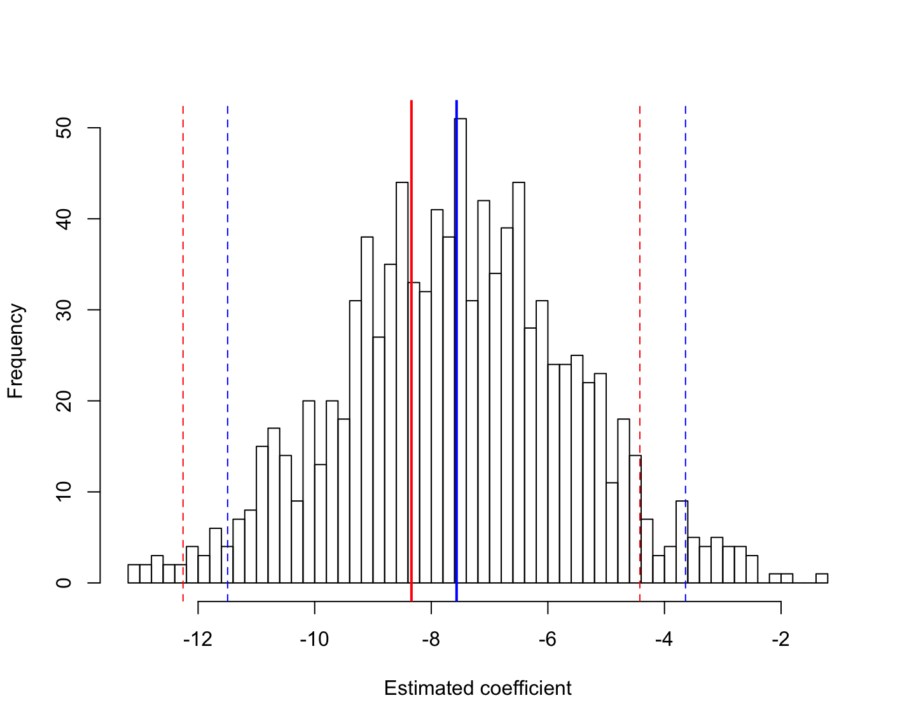

**Appendix 3** – Results of randomization tests. Histogram shows the estimated coefficient for the effect of allopatric relative to sympatric status on coefficient of variation in performance. The solid red line corresponds to the original model estimated parameter value using all available maternal families. The solid blue line corresponds to the mean of 1000 iterations where 11 maternal families were randomly chosen from each monarch population. Dotted lines correspond to 95% confidence intervals. Randomization tests did slightly reduce the magnitude of variation, but this was mainly due to shrinkage of all model parameters towards 0.